**MyApplication**

Исходный код проекта:

<https://github.com/verkhoumov/AndroidLabs/tree/master/MyApplication>

Скриншоты экрана:

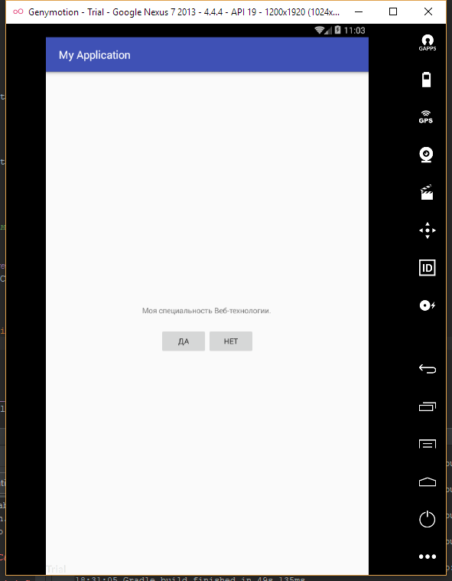

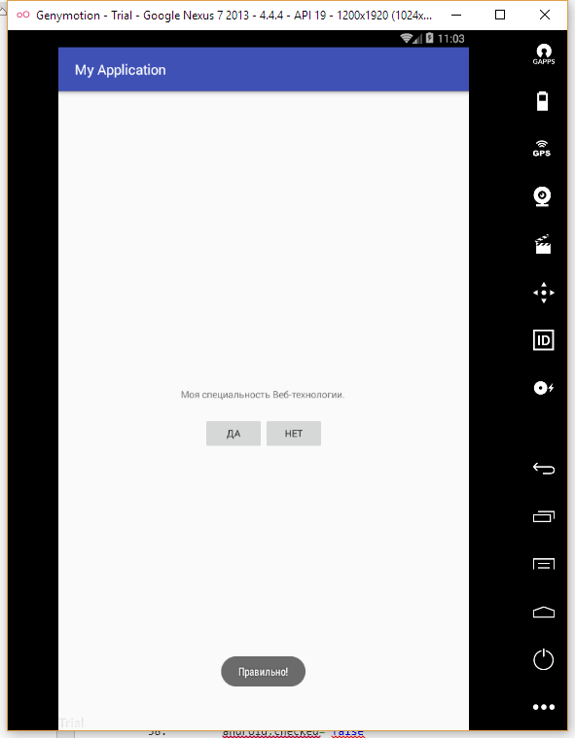

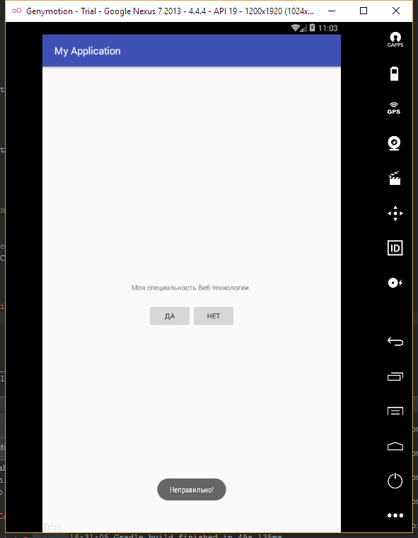

Исходный код.

TestActivity.java:

1. **package** ru.verkhoumov.myapplication;
3. **import** android.support.v7.app.AppCompatActivity;
4. **import** android.os.Bundle;
5. **import** android.view.View;
6. **import** android.widget.Button;
7. **import** android.widget.Toast;
9. **public** **class** TestActivity **extends** AppCompatActivity {
10. **private** Button mYesButton;
11. **private** Button mNoButton;
13. @Override
14. **protected** **void** onCreate(Bundle savedInstanceState) {
15. **super**.onCreate(savedInstanceState);
16. setContentView(R.layout.activity_test);
18. ***/\*\****
19. ***\* Привязываем кнопки к элементам приложения и вешаем***
20. ***\* событие нажатия на каждую из них.***
21. ***\*/***
22. mYesButton = (Button) findViewById(R.id.yes_button);
23. mYesButton.setOnClickListener(**new** View.OnClickListener() {
24. @Override
25. **public** **void** onClick(View v) {
26. Toast
27. .makeText(TestActivity.**this**, R.string.correct_answer, Toast.LENGTH_LONG)
28. .show();
29. }
30. });
32. mNoButton = (Button) findViewById(R.id.no_button);
33. mNoButton.setOnClickListener(**new** View.OnClickListener() {
34. @Override
35. **public**  **void** onClick(View v) {
36. Toast
37. .makeText(TestActivity.**this**, R.string.incorrect_answer, Toast.LENGTH_LONG)
38. .show();
39. }
40. });
41. }
42. }

activity_test.xml:

1. **<?xml** version="1.0" encoding="utf-8"**?>**
2. **<LinearLayout** xmlns:android="http://schemas.android.com/apk/res/android"
3. android:layout_width="match_parent"
4. android:layout_height="match_parent"
5. android:gravity="center"
6. android:orientation="vertical"**>**
8. **<TextView**
9. android:layout_width="wrap_content"
10. android:layout_height="wrap_content"
11. android:padding="24dp"
12. android:text="@string/question_go" **/>**
14. **<LinearLayout**
15. android:layout_width="wrap_content"
16. android:layout_height="wrap_content"
17. android:orientation="horizontal"**>**
19. **<Button**
20. android:id="@+id/yes_button"
21. android:layout_width="wrap_content"
22. android:layout_height="wrap_content"
23. android:text="@string/yes_button" **/>**
25. **<Button**
26. android:id="@+id/no_button"
27. android:layout_width="wrap_content"
28. android:layout_height="wrap_content"
29. android:text="@string/no_button" **/>**
30. **</LinearLayout>**
31. **</LinearLayout>**

strings.xml:

1. **<resources>**
2. **<string** name="app_name"**>**My Application**</string>**
3. **<string** name="question_go"**>**Моя специальность "Веб-технологии".**</string>**
5. **<string** name="yes_button"**>**Да**</string>**
6. **<string** name="no_button"**>**Нет**</string>**
8. **<string** name="correct_answer"**>**Правильно!**</string>**
9. **<string** name="incorrect_answer"**>**Неправильно!**</string>**
11. **<string** name="action_settings"**>**Settings**</string>**
12. **</resources>**